Binary subarray with sum
Problem Statement: You are given a binary array nums (containing only 0s and 1s) and an integer goal. Return the number of non-empty subarrays of nums that sum to goal. A subarray is a contiguous part of the array.
Examples
Input: nums = [1, 0, 0, 1, 1, 0], goal = 2
Output: 6
Explanation: There are 6 subarrays with sum exactly equal to 2:
[1, 0, 0, 1], [0, 0, 1, 1], [0, 1, 1], [1, 1], [1, 1, 0], [0,0,1,1,0]

Input: nums = [0,0,0,0,0,0], goal = 0
Output: 21
Explanation: All subarrays with only 0s will have sum = 0.
There are 21 such subarrays in total (n(n+1)/2 = 6*7/2 = 21).
Algorithm
To count the number of subarrays with sum exactly equal to goal, a clever strategy is to reframe the problem: We count the number of subarrays whose sum is at most goal, and subtract from it the number of subarrays whose sum is at most goal- 1.
This works because:The subarrays with sum exactly goal are the ones included in atMost(goal) but not in atMost(goal - 1) and This is valid for non-negative elements.
Why is this more efficient?
Instead of recomputing subarray sums from scratch , we maintain a sliding window that expands and contracts based on the current sum.This gives us linear time performance by moving each pointer at most once. This method only works when goal ≥ 1, because the atMost(goal - 1) calculation is invalid for goal = 0 (negative index/window not possible).
- Define a helper function to calculate the number of subarrays with sum at most a given value
- Initialize a sliding window with two pointers (left and right)
- Iterate through the array, expanding the right pointer and adding to current sum
- If the current sum exceeds the target, shrink the window from the left until it’s valid
- At each step, add the size of the current valid window to the count
- To get the final answer, compute: atMost(goal) - atMost(goal - 1)
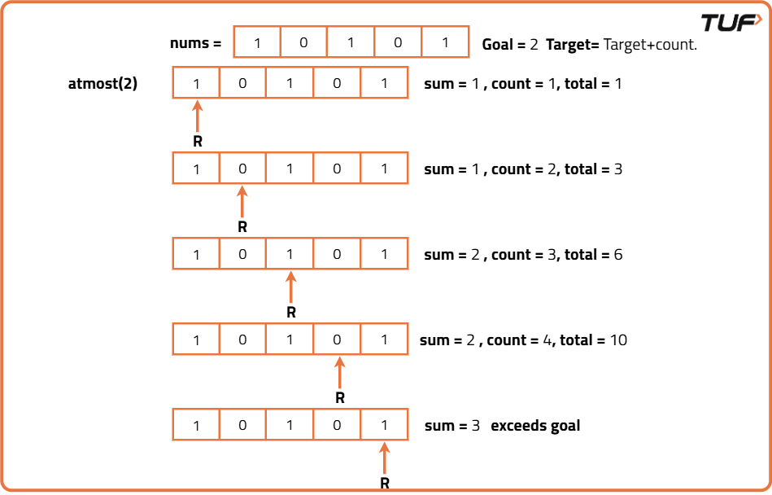

class Solution {
public int numSubarraysWithSum(int[] nums, int goal) {
// Return difference between atMost(goal) and atMost(goal - 1)
return atMost(nums, goal) - atMost(nums, goal - 1);
}

// Helper method to count subarrays with sum at most k
private int atMost(int[] nums, int k) {
// No valid subarray for negative sum
if (k < 0) return 0;
int left = 0, sum = 0, count = 0;
for (int right = 0; right < nums.length; right++) {
sum += nums[right];
while (sum > k) {
sum -= nums[left];
left++;
}
// Add number of valid subarrays ending at right
count += (right - left + 1);
}
return count;
}
}
Time Complexity: O(n), where n is the size of the input array.This is because the algorithm uses the sliding window technique twice (in the two calls to atMost). Each `atMost` function runs in linear time , the left and right pointers only move forward, never backward, so the total number of operations is at most 2n.
Space Complexity: O(1), constant extra space.Only a few integer variables are used .

